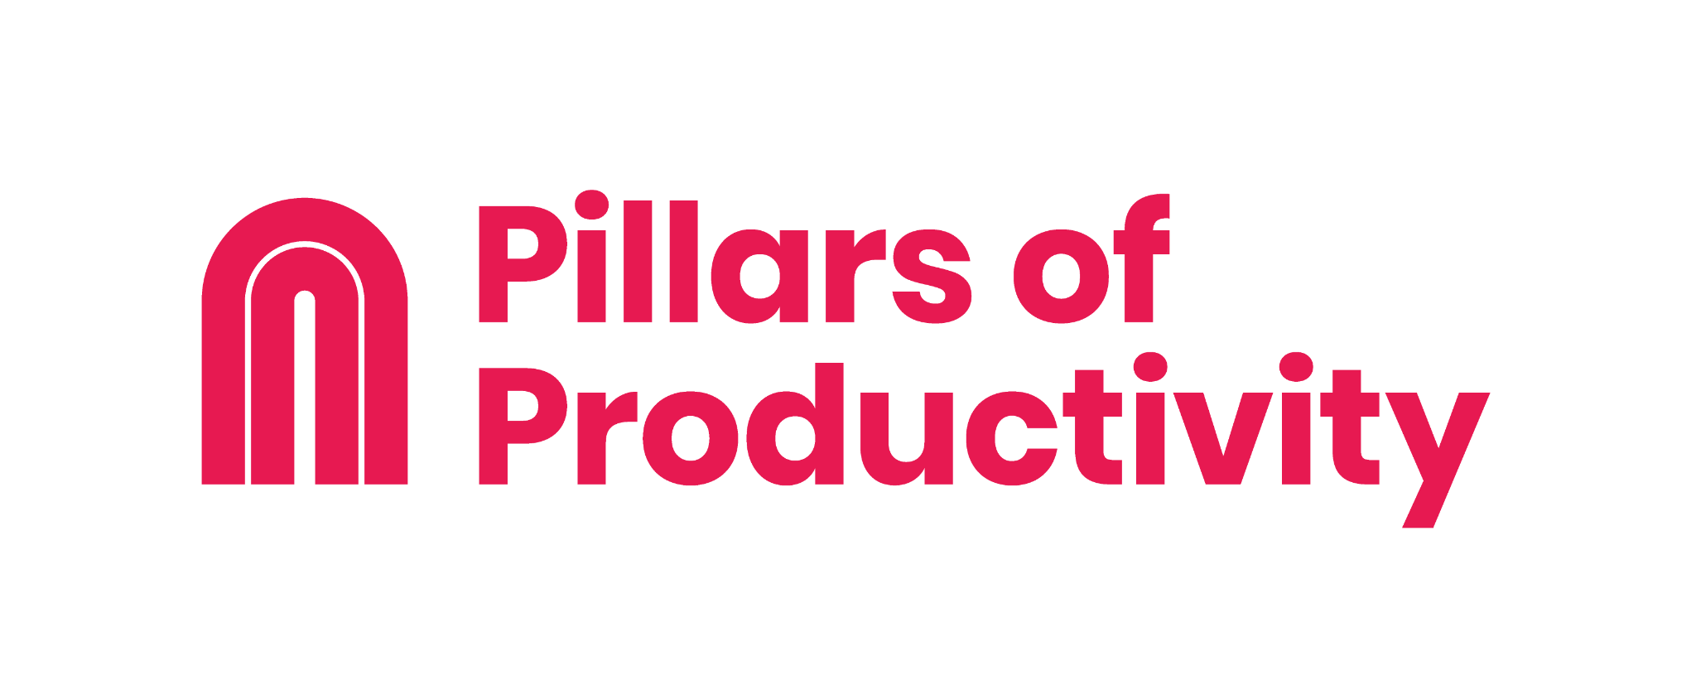
Workbook for …………………….

1. Introduction

The Pillars of Productivity System
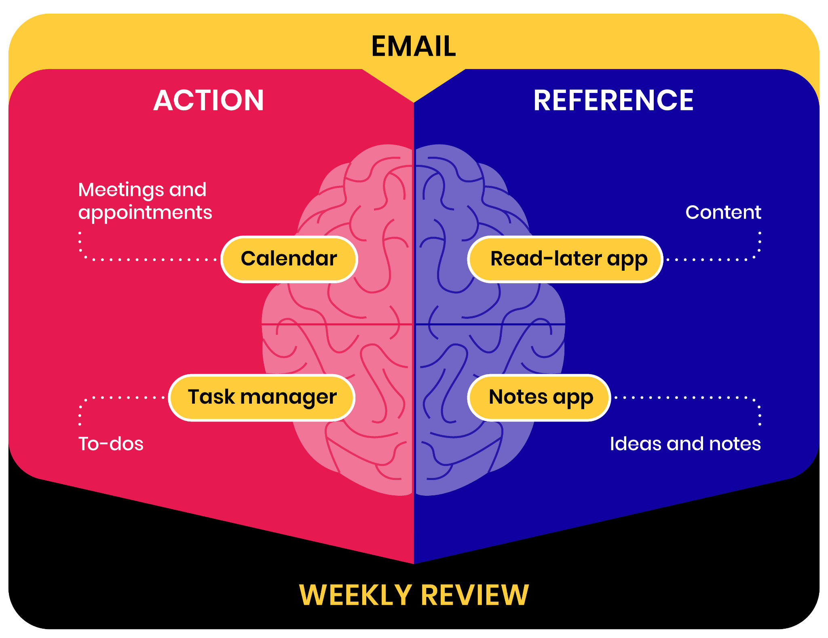

Heaven & Hell Journal Exercise

Hell
Imagine yourself 12 months from today. In this version of the future, you haven’t finished this course, haven’t made any changes in your productivity, and your life has become increasingly chaotic, with an overflowing email inbox and ever-growing to-do list.

Set a timer for 5 minutes and write about what that feels like. What are some of the downstream consequences to your work, your relationships, and your hopes and dreams for the future? What does a day in your life look like?

[Type your answer here]

Heaven
Now, imagine that same day 12 months from now, but this time you prioritized the practices and tools you learned from this course to create a system for sustainable productivity that provides you with clarity and motivation every day.

What are the effects of this on the quality and output of your work and creativity? How did your relationships change at work and at home? What transformation did you observe? Set a timer for 5 minutes again and write down what comes to mind.

[Type your answer here]

2. Email: Getting to Inbox Zero

Mindset Shift
Email is not your job: Your inbox is someone else’s to-do list. It’s not where your true creativity and value shine.

Practice batch processing: Instead of replying to emails one at a time as they come in, let them accumulate and then clear them all in one go. Aim to wipe the slate clean completely and reach inbox zero once per week.

Step 1: Strip Email Down To Its Core Function
Perform the following actions in your Gmail settings. (These settings will exist on any other email platform as well, potentially with a slightly different name.)

- Turn on "Show Send & Archive” button in the General tab
- Turn on "Conversation view" in the General tab
- Turn off "Mail notifications" in the General tab under desktop notifications
- Turn on keyboard shortcuts in the General tab (and familiarize yourself with them)
- Select Promotions, Social, and Updates in the Inbox tab
- Enable "auto-advance" in the Advanced tab, then select “Go to the next (newer) conversation” in the General tab under auto-advance
- Add other email addresses of yours in the Accounts & Import tab

Don’t forget to click “Save Changes” at the bottom of the screen.

Step 2: Set Up the 4 Downstream Systems
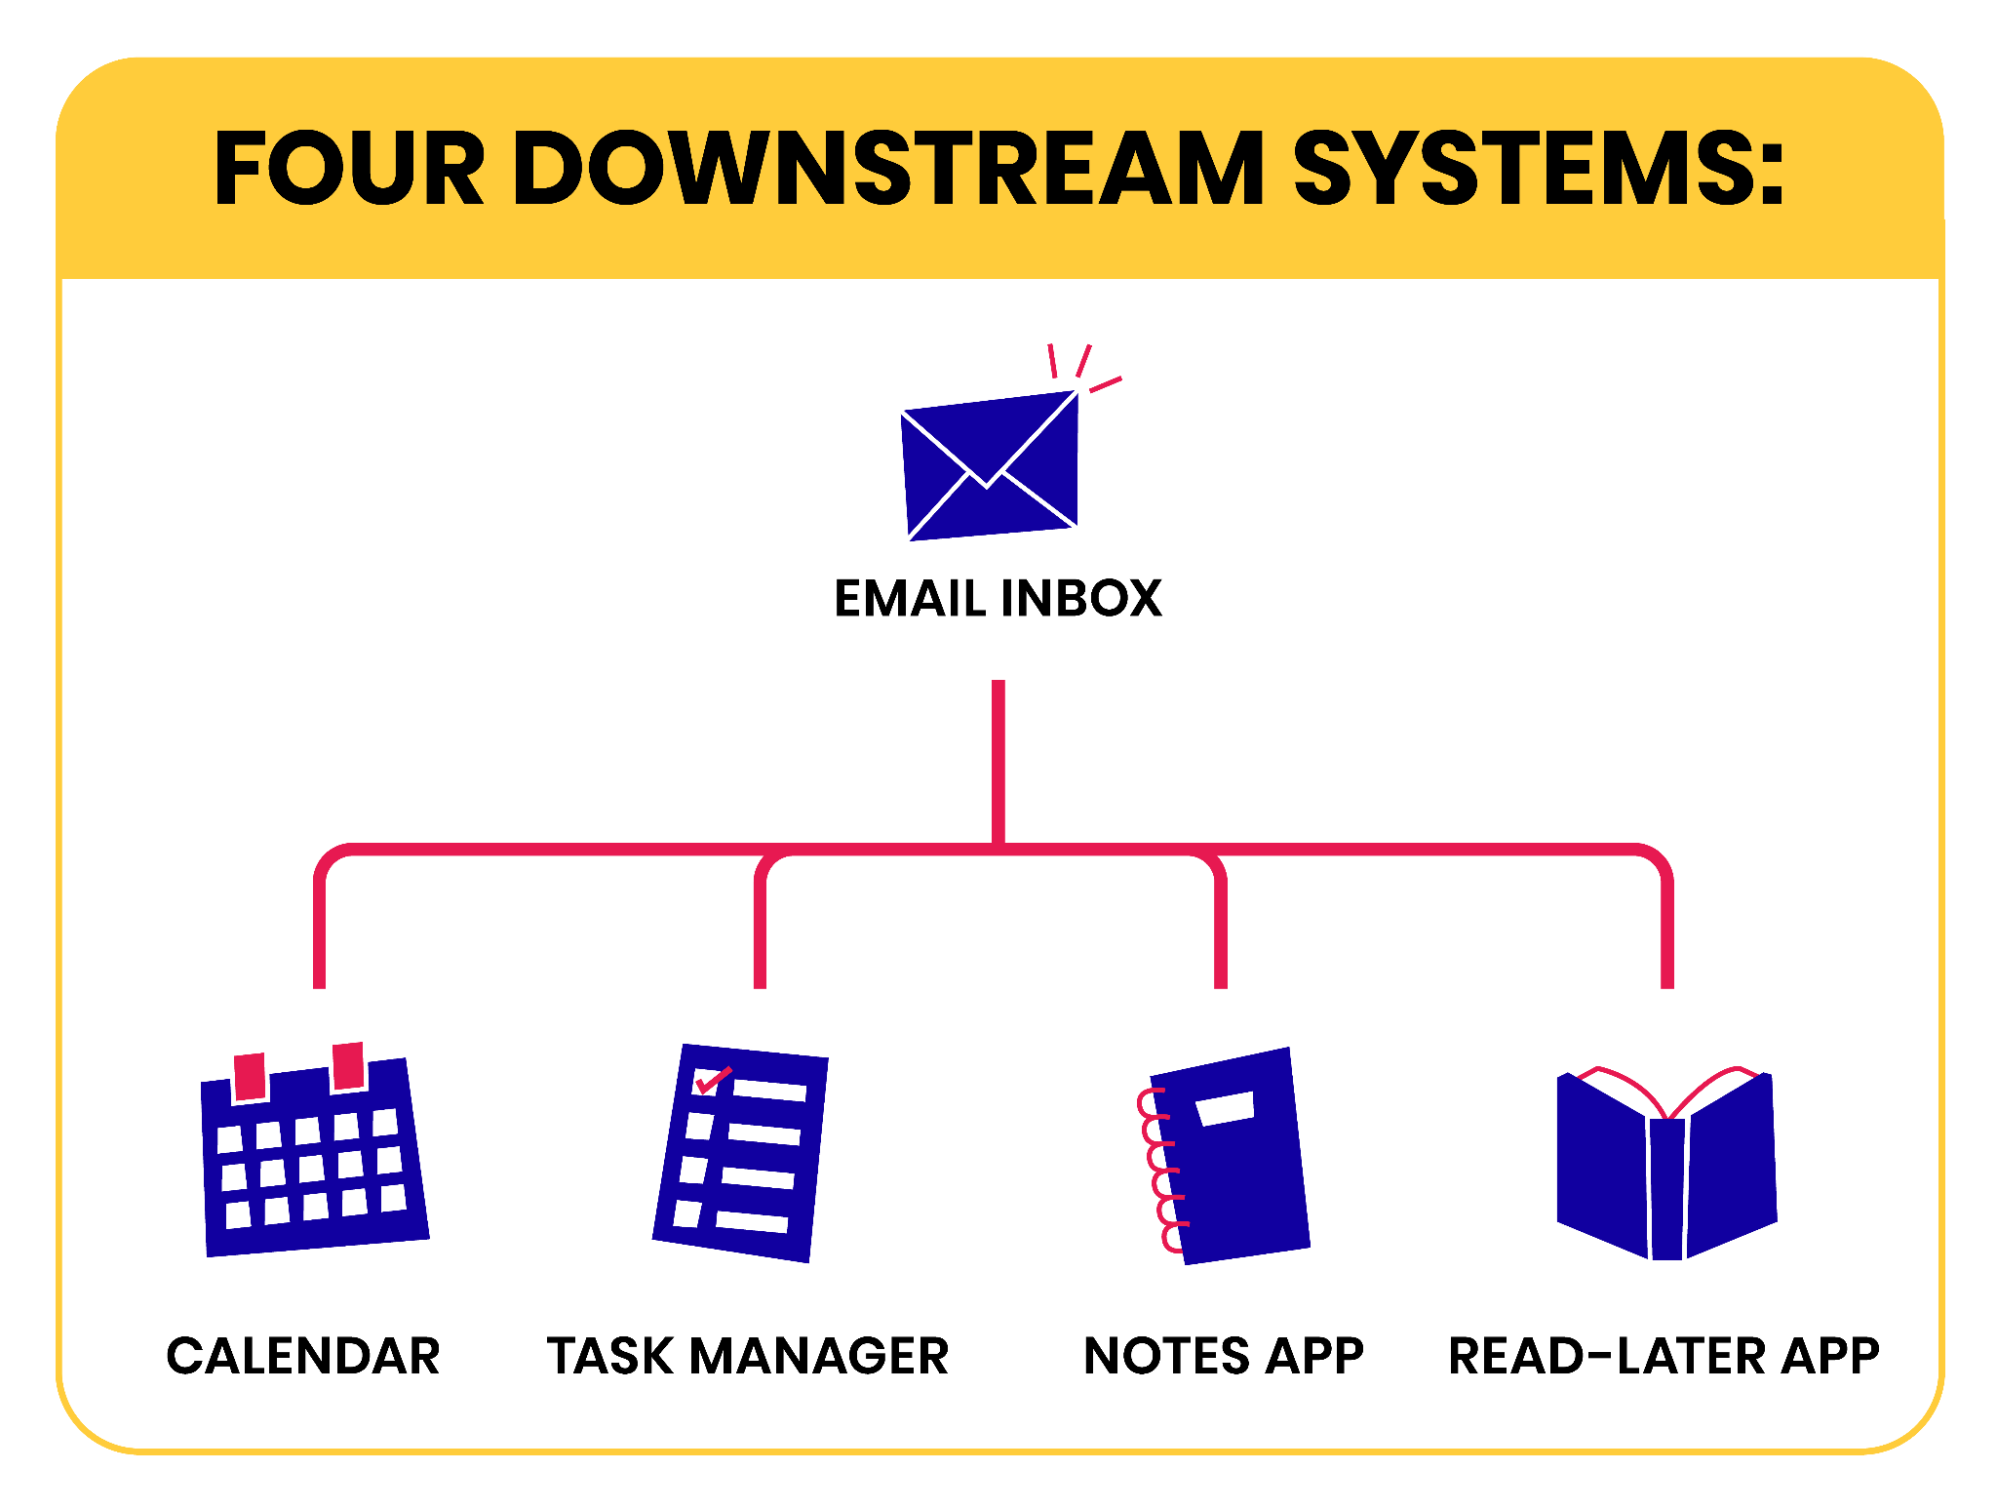

Watch lessons 3-6 for in-depth explanations on how to set up these four essential productivity systems.

- Digital calendar
- Task manager
- Notes app
- Read-later app

Step 3: Practice Triage
Triage = deciding WHAT needs to be done WITHOUT actually doing it.

Every time you sit down to clear your emails, start with the oldest message in your inbox. Then go one at a time, in the order they were received, taking one of these six actions:
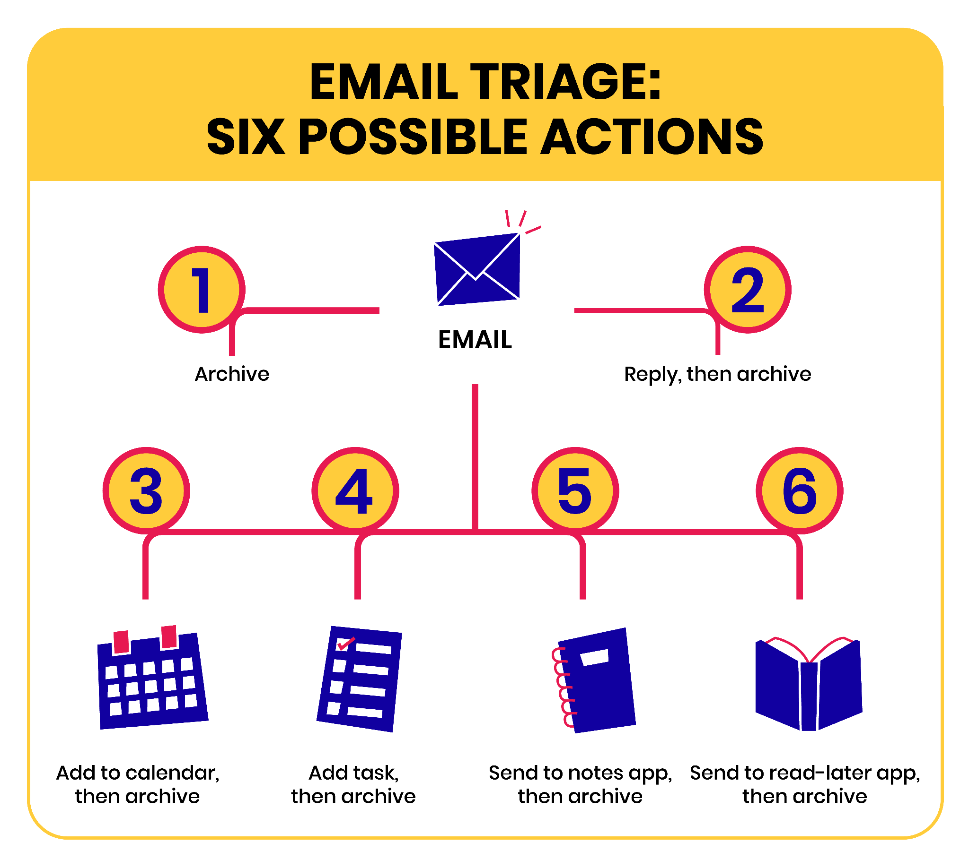

Reflections

Your "Aha!" Moment
What was your most eye-opening strategy or realization from this lesson? How did it change your view of email management?

[Type your answer here]

3. Calendar: Managing Your Time

Mindset Shift
Think of your calendar as the "hard landscape" for non-negotiable commitments (e.g., meetings, calls, appointments, flights) so you always know where you have to be at any given time.

Digital Calendar Setup
- Download a calendar app (see recommended apps in Circle)
- Connect all your calendar accounts to your calendar app, for example…
  - Personal email address
  - Work email address
- Sync your calendar across all devices, for example…
  - Smartphone
  - Tablet
  - Laptop
  - Desktop computer
- Create or enable specialized calendars, for example…
  - Company/school events
  - Holidays in your country
  - Birthdays
  - Your partner’s calendar

Four Rules for Managing Your Time
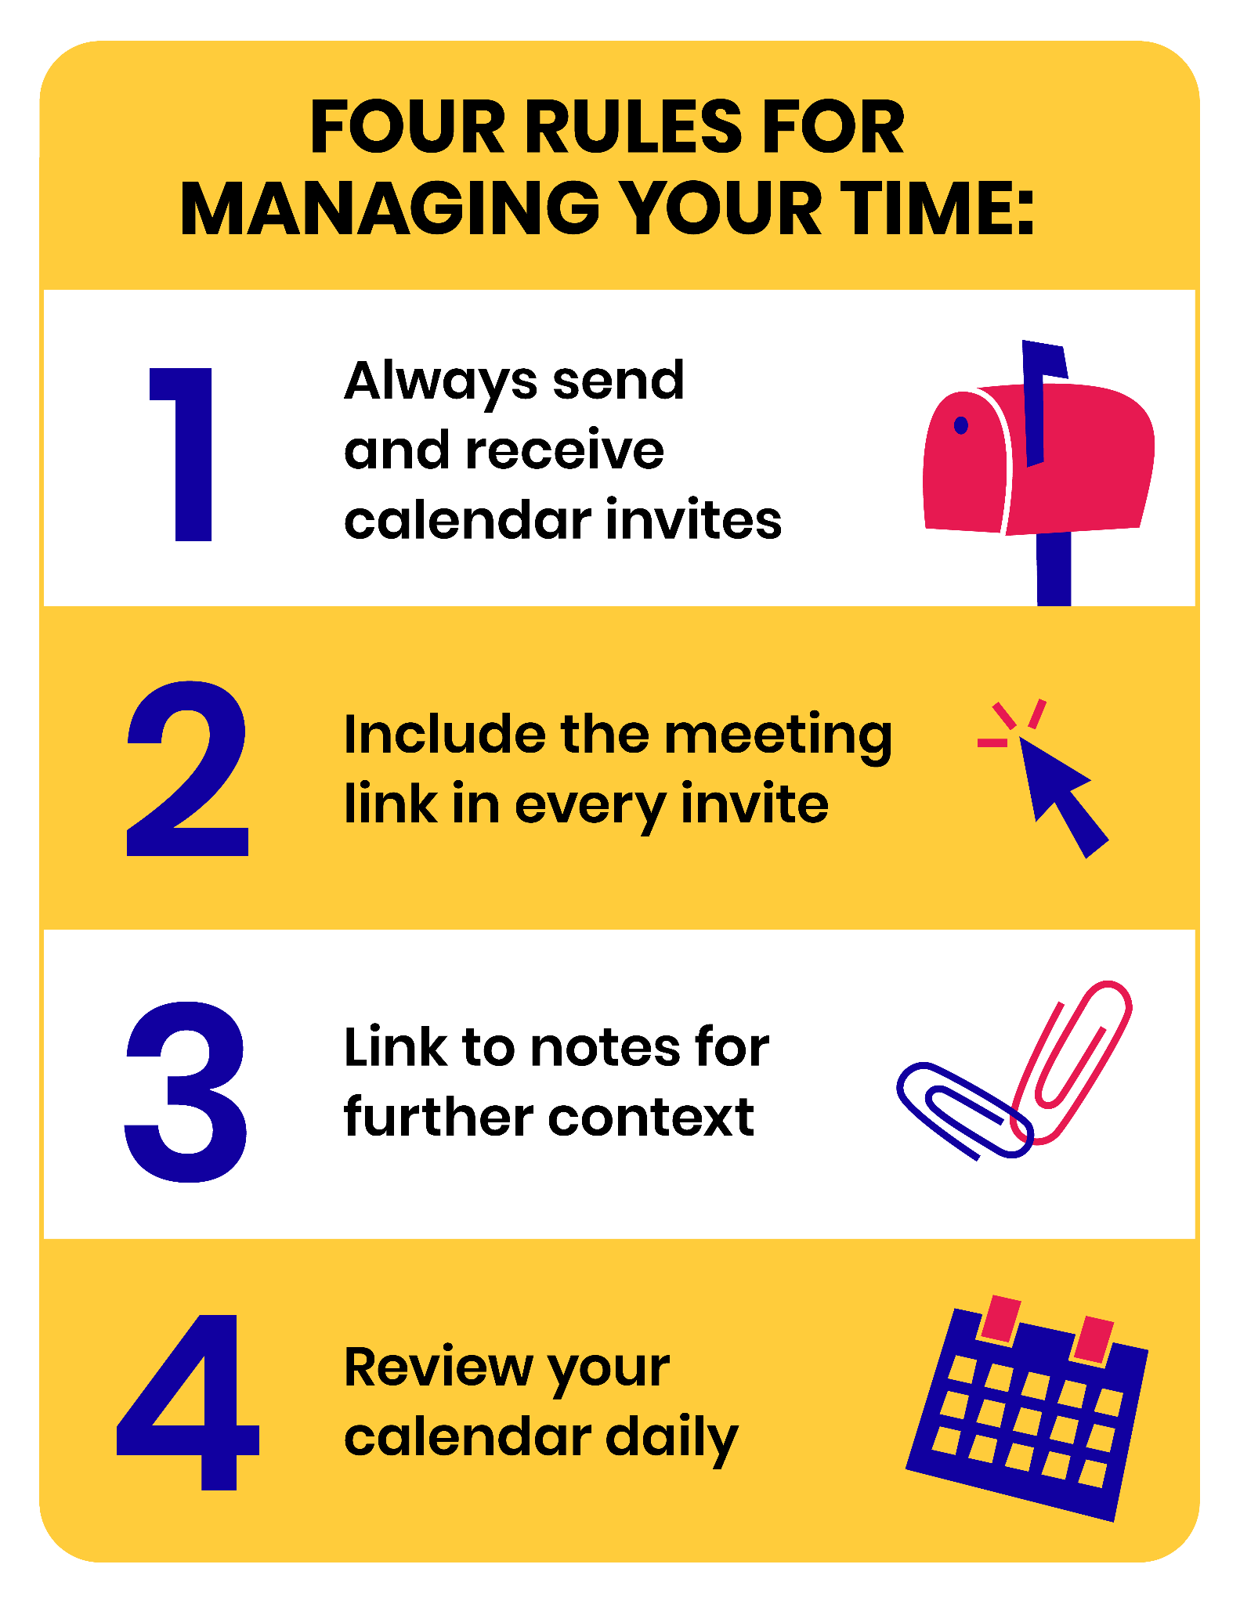

Reflections

Biggest Takeaway
What's the most significant change or improvement you've noticed after setting up and finetuning your digital calendar?

[Type your answer here]

Calendar Rules
Which of the calendar rules shared in the lesson resonated the most with you? Have you adopted any additional personal rules?

[Type your answer here]

4. Tasks: Taming Your To-Do List

Mindset Shift
You have far more things you could do than you're actually able to do. In other words, you are never going to reach the end of your to-do list. This means you can let go of any sense of guilt or shame you have about not finishing it for good.

Task Manager Setup
- Download a task management app (see recommended apps in Circle)
- Install it on all of your devices, for example…
  - Smartphone
  - Tablet
  - Laptop
  - Desktop computer
- Familiarize yourself with the main features of the app
  - Sidebar
  - Quick capture shortcut
  - Inbox (or Daily Notes page)
  - “Today” (or “This Week”) view
  - Folders or tags (for projects and areas)
  - Creating new tasks (and linking to notes)
  - Priority levels
  - Moving tasks

Key Concept: Open Loops
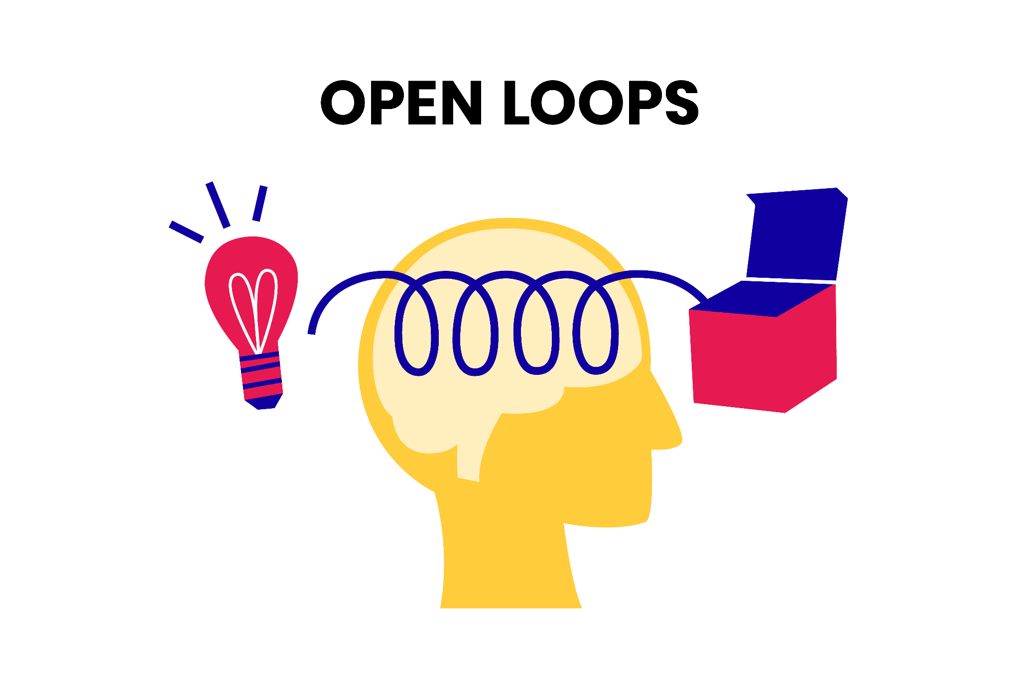
Any new commitment or piece of information in your environment is an "open loop" that requires your attention and takes up ongoing mental bandwidth. You can close an open loop by completing the task immediately, or by capturing it in a trusted system outside your head.

Using Your Task Manager
- Use the quick capture feature to jot down open loops as soon as they arrive
- Use autofill to link associated information (like emails, webpages, and documents) to tasks
- Batch-process your task inbox:
  - Reword tasks for clarity, using specific, actionable verbs
  - Apply a high-priority tag to urgent tasks
  - File tasks either in an active project or a general area of your life or work

Reflections

Mindset Shift
Reflect on the idea that you'll never reach the end of your to-do list. How does this realization make you feel? Have you let go of the guilt or shame associated with an ever-growing list?

[Type your answer here]

Open Loops
Reflect on an experience where an "open loop" caused you stress or anxiety. How have you started using your task manager to close these open loops and how has it changed your overall well-being?

[Type your answer here]

5. Notes: Taking Notes Effectively

Mindset Shift
All the information you consume, read, produce, interact with, or save is potentially valuable, an asset worth keeping and preserving over time. Your digital notes are a reserve of intellectual raw material that grows and compounds in value over time.

Notes App Setup
- Pick a notes app that suits your needs using this video series or this blog post
- Download the notes app you selected and install it on all of your devices, for example…
  - Smartphone
  - Tablet
  - Laptop
  - Desktop computer
- Designate an inbox, for example, by creating a folder and titling it “Inbox”
- Practice the following actions…
  - Create a new note
  - Add an image or attachment to your note
  - Add formatting to a piece of text, such as bold or highlight
  - Practice keyboard shortcuts
  - Generate a link to a note, and then paste it into another note, and a task in your task manager
  - Move a note from one folder to another, or apply and then remove tags
  - Move groups of notes from one place to another
- Familiarize yourself with the different ways of getting content into your notes (each notes app offers different capture methods and may not support all the ones mentioned here)
  - Forward the contents of an email directly to your notes
  - Quickly capture text during meetings or video calls
  - Drag and drop files or images directly into the notes app
  - Add the mobile app to your phone's dock, so you can start typing within seconds
- Create a folder or tag for each of your active projects

Clear Your Notes App Inbox
Clear your inbox by moving notes into the relevant folders (or tagging them with the relevant tags). Consider the following optional steps for each note you touch:

- Change the title of the note to something more specific and informative
- If a note requires a follow-up action, capture this task in your task manager, copying the link to this specific note into the task

Reflections

Notes App
Which digital notetaking app did you choose and why?

[Type your answer here]

Win
What's one change or benefit you've noticed after transitioning to digital notetaking?

[Type your answer here]

6. Content: Using a Read-Later App

Mindset Shift
Challenge the notion of only having two choices for when to consume a piece of content: now or never. Instead, embrace the concept of consuming content "later" – setting it aside for a separate, intentional time.

This is how you avoid being trapped between Information Overload on one side and FOMO, the Fear of Missing Out, on the other side.

Read-Later App Setup
- Pick a read-later app (see recommended apps in Circle)
- Install it on all of your devices, for example…
  - Smartphone
  - Tablet
- Install the browser extension
- Move the read-later app on your phone and tablet to a prominent place
- Add the read-later app's personalized email address to your contacts
- Practice using the app by trying common actions, such as:
  - Forward an email to your read-later app
  - Save a webpage using the browser extension
  - Right-click to save links to the app

Five Best Practices
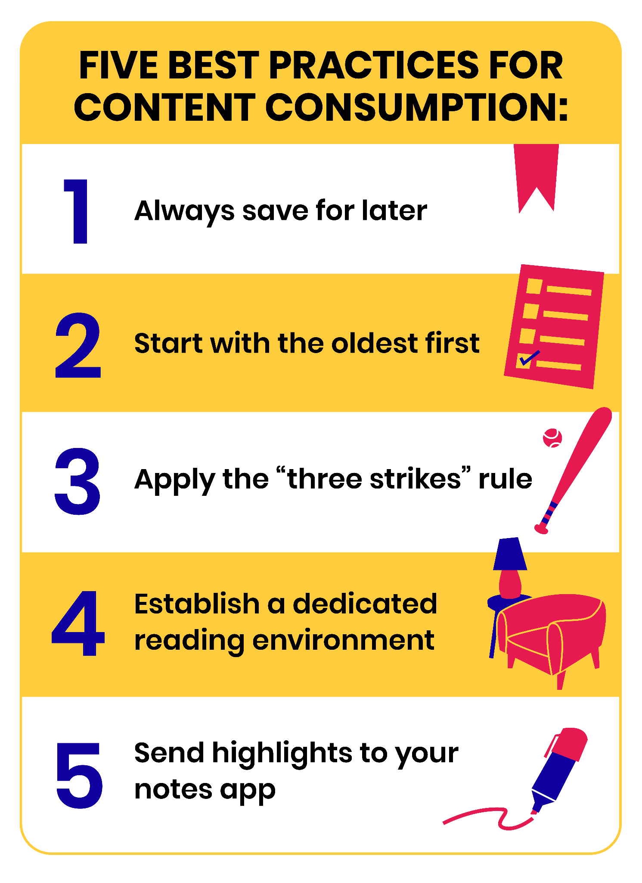

- Always opt to save content for later, even if you feel you have the time now
- Sort your reading list starting with the "oldest saved" items
- Apply the "3 strikes rule," archiving items you've skipped three times
- Establish a dedicated reading environment (e.g., a tablet optimized for content consumption)
- Integrate your read-later app with your primary notes app with a service such as Readwise

Develop Your Content Consumption Checklist
We recommend you sit down and make a prioritized list of what content you want to fill your mind with. From most desired to least, create a plan for your future self to follow so you make that decision more intentionally.

Example: Tiago’s reading checklist in order of priority
- Books (ebooks for research-based reading and paper books for pleasure reading)
- Long-form articles (in a read-later app)
- YouTube videos and podcasts (easy to consume when tired or doing chores)

Reflections

Mindset Shift
How has introducing a read-later app affected your daily content consumption habits? How are you perceiving Information Overload or FOMO now?

[Type your answer here]

Content Consumption Checklist
Which content sources are you prioritizing? (e.g., books, blog posts, YouTube videos, podcasts)

[Type your answer here]

7. Weekly Review: Winning Every Week

Mindset Shift
A Weekly Review is not an all-encompassing, total overhaul of your entire life from top to bottom. It’s a quick reset of your digital world so you can start the upcoming week clean.

The purpose of a Weekly Review is to:
- Finish the past week with a sense of completion, finality, and fulfillment
- Start the next week with a sense of clarity and purpose, based on thoughtful preparation

The Four-Step Weekly Review Process
Remember the phrase "Every Commitment Needs Tracking" (ECNT), which corresponds to the four steps: Email-Calendar-Notes-Tasks.

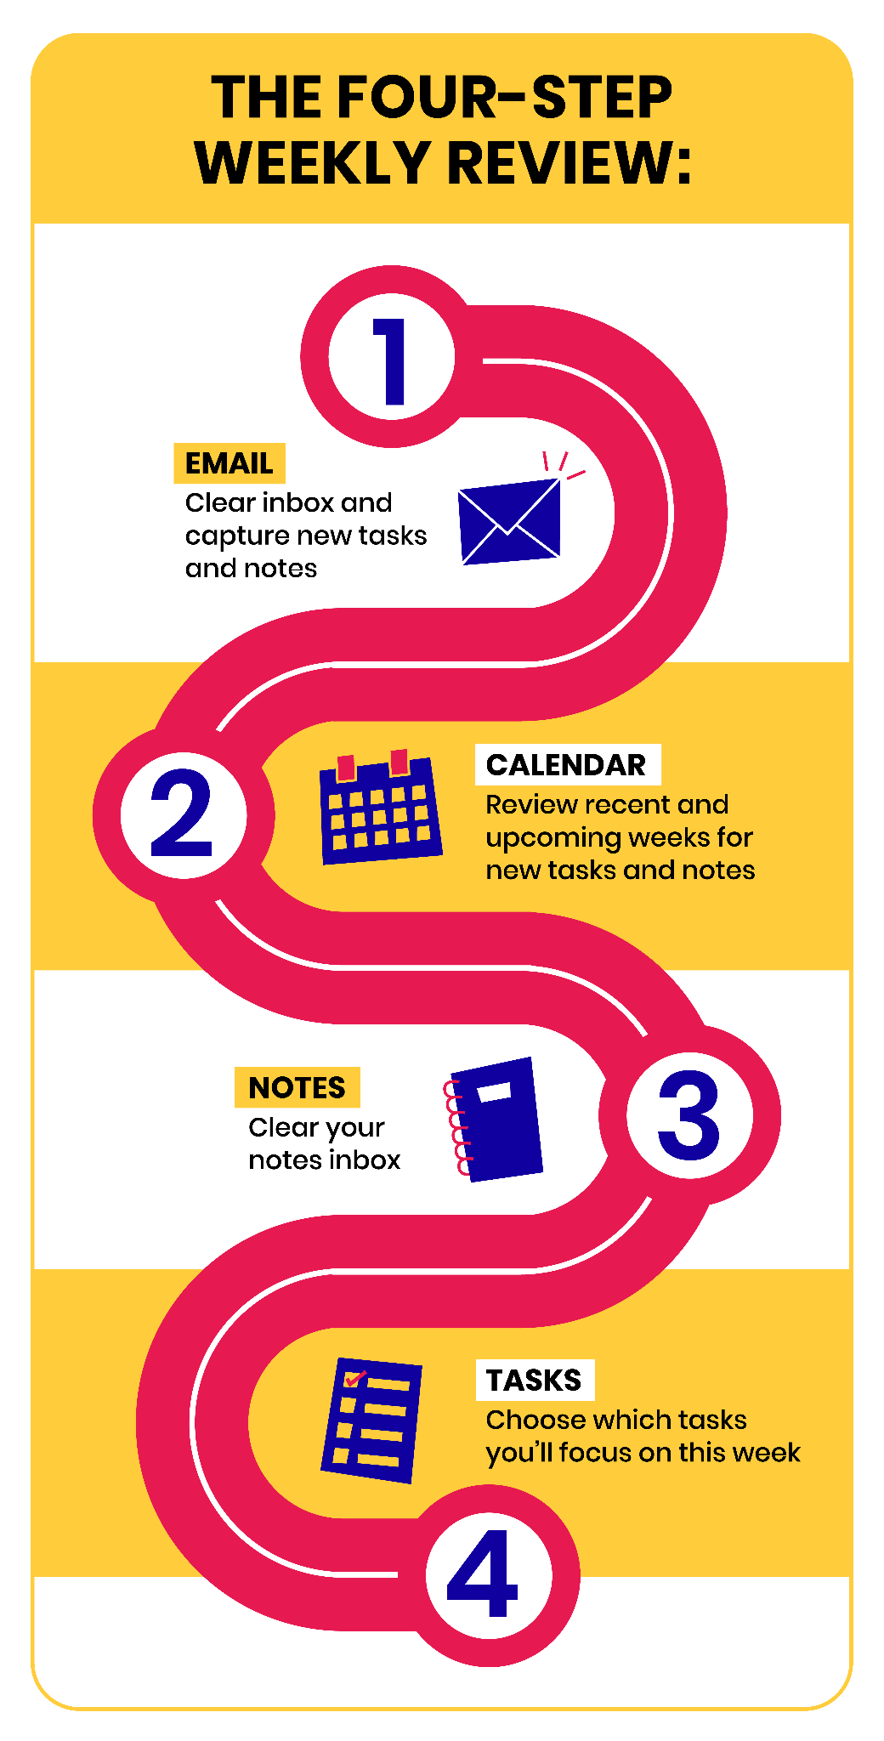

Clear your emails
Start with the oldest message in your inbox and practice triage, taking one of these six actions:
- Archive
- Reply, then archive
- Add to calendar, then archive
- Create a task, then archive
- Send to notes app, then archive
- Send to read-later app, then archive

Review your calendar
Check the last two weeks in your calendar for any follow-up items. Then check the upcoming two weeks for any appointments you need to prepare for. Add any tasks that arise to your task manager.

File your notes
Clear your notes inbox by moving new notes into the relevant folders (or tagging them with the relevant tags). Consider the following optional steps for each note you touch:

- Change the title of the note to something more specific and informative
- If a note requires a follow-up action, capture this task in your task manager, copying the link to this specific note into the task

Optional: You can also take a moment here to capture notes from other sources, such as:
- Paper notebook (snap a photo using your notes app’s mobile app)
- Downloads folder (add any files you've downloaded and want to save to your notes by dragging and dropping them into the notes app)
- Desktop (add any working files that have accumulated here that you want to save by dragging and dropping them into the notes app)

Choose tasks
You’ll now decide: Out of all the things you could do this upcoming week, what will you do this week?

3 ways to filter your full list of tasks:
- Focus on high-priority tasks first.
- Check for tasks labeled "waiting for" to identify any responses you are waiting on or follow-up actions you need to take.
- Categorize tasks by project to determine which projects to prioritize for the week.

Compile your "This Week" list as your game plan for the upcoming week. Instead of wondering what to do next, you’ll always come straight back to this list and ignore everything else.

Note that your game plan can and should change. As more information comes to light and the week unfolds, you can reword tasks to be more specific, add or remove them to your list for the week, and move them around to reflect changing priorities.

Reflections

Weekly Review Process
As you went through the steps to clear your email, review your calendar, file notes, and choose tasks, did you find any particular step more challenging or rewarding than the others? Why do you think that is?

[Type your answer here]

Tips & Tricks
Have you added any personal touches or hacks to the process that you found particularly helpful?

[Type your answer here]

8. Next Steps

Reflections

Reflect Backwards
What are the top five things you want to remind yourself of in the months and years to come? An easy way to do this is to review your notes and highlight the most resonant takeaways.

[Type your answer here]

Reflect Forwards
Looking forward to the next six months, ask yourself what might get in the way of implementing what you’ve learned. What form might your resistance take? What will be the greatest challenges or obstacles that you can anticipate ahead of time?

[Type your answer here]

Open Questions
What questions were left unanswered by the course? Which challenges are you still facing?

[Type your answer here]

Take the Completion Survey
Please take a few minutes to complete this survey.

It serves as an opportunity for you to reflect on your personal growth throughout the course, and a chance to provide feedback that will shape future updates to the experience.

